## Name: Laura C. Larregui Date: January 14, 2020

## Lab 02 - Conceptual Modeling

Part 1 – Conceptual Modeling Case Studies

1. Case Study 1- Obligatory College Classes Modeling

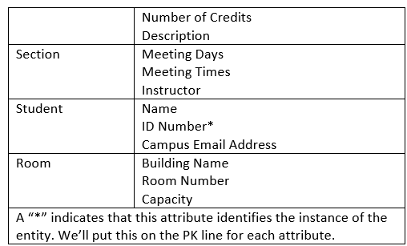

1. 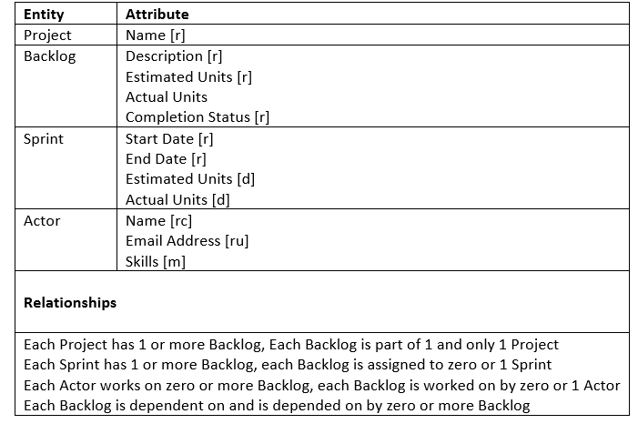Case Study 2- Project Management

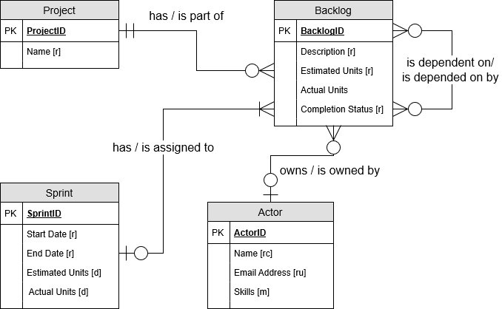

1. Case Study 3- Book Publishing Database

|  |  |
| --- | --- |
| **Entity** | **Attribute** |
| Publisher | PublisherID*  Name [r]  Mailing Address [rc]  Telephone Number [ru] |
| Book | BookID*  ISBN [ru]  Title [r]  Price [r]  Number of Pages [r] |
| Royalty Check | CheckID*  Check Number [ru]  Amount [rd]  Date [r] |
| Author | AuthorID*  Name [rc]  Address [rc]  Royalty Rate [m] |
| **Relationships** | |
| A Publisher publishes one or more Books, Books have only one Publisher.  A Book is written by one or more Authors, Authors write one or more Books.  Authors are represented by one or more Publishers, Publishers represent one or many Authors.  An Author receives one or more Royalty Checks, a royalty check is assigned to only one author. | |

Part 2 – VidCast Conceptual Model

